GAYDON PARISH COUNCIL
Clerk to the Council: Corinne Hill, Gaydon Fields Farm, Gaydon, Warwickshire CV35 0HF
01926 641220
Email: parishclerk86@btinternet.com
14th May 2016
Response to 16/00288/FUL
Gaydon Parish Council objects on a conditional basis to the application. This is not to say that we oppose the intent behind the application – indeed, JLR appears to be making an earnest attempt to improve the local area and rectify several issues that have posed challenges to both the company and Gaydon over the years. However, there are many facets of the plan that would need to be addressed before GPC could consider lending its support, lest the parish become the victim of the unintended consequences what is evidently a well-intentioned proposal.
EEAs and the Land to the North of Gaydon
The Ecological Enhancement Areas and their associated changes to the topography of the land to the immediate North of Gaydon are, in principle, a good idea. However, certain details of the plan cause concern. Firstly, EEA1 whilst offering fairly robust flood protection towards the main part of Gaydon, directs surface runoff towards the southwest, directing water across the fields towards the Kineton Road and Gardener’s Cottage. These areas are already suffering from inundation after heavy rainfall, and adding to the water that already drains towards there is not acceptable. GPC feels that this could be mitigated by curving the planned barrier at EEA1 back towards the north in a crescent shape in order to hold the water back. Water draining straight across the fields from the leylandii at EEA2 could also be mitigated by changing the lay of the land to form a slight depression at the foot of the hillside, or by creating a SUDS nearer to Gardener’s Cottage. There is also concern over the removal of topsoil at the EEA1 site itself, and the detrimental effect that this may have on the ability of the area to hold water.
Secondly, GPC would like to affirm that the leylandii at EEA2 is reinforced with both coniferous and deciduous trees, so that effective screening of the JLR site is maintained all year round. This is especially important given the proposed lighting scheme for the new parking areas.
Thirdly, the land marked as a ‘habitat area’ is not presently owned by JLR. What assurances are there that this aspect of the plan will go ahead, and if it will, how can JLR be certain that it will be maintained in keeping with the EEA1 development?
Fourth, the proposed ponds in EEA1 could be made somewhat deeper to account for the somewhat inevitable silting-up that will occur over time as surface runoff carries mud and debris downhill into them.
Fifth, GPC would like to stress that water from EEA2 must be prevented from draining towards Chadshunt where possible. The area has had problems with flooding in the past and with the new ditch directing water to the southwest, it may see more serious problems arise. Perhaps some kind of attenuation pond may be appropriate at the far end of EEA2?
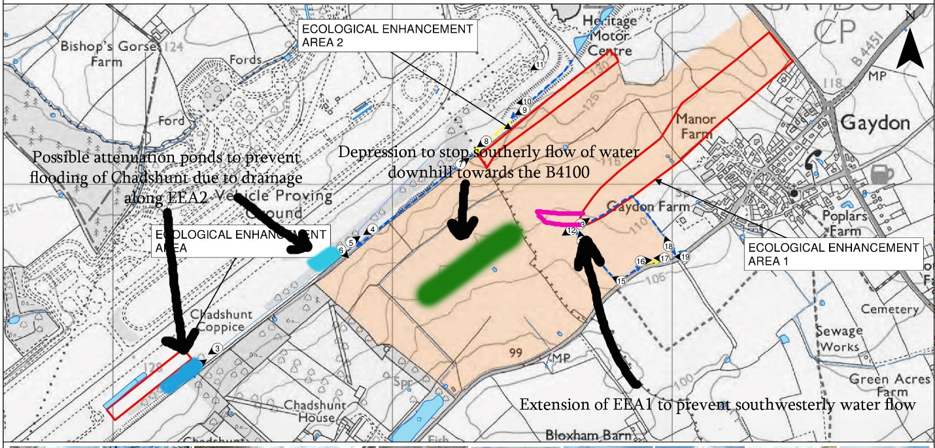

Lighting
A main concern GPC is the impact that development of the JLR site will have upon the rural character of the village. The application details the construction of new parking areas and their associated lighting systems. Although GPC supports JLR’s decision to add more parking facilities to their site (as this will undoubtedly help to alleviate rush-hour congestion), we do have significant concerns with regards to the lighting aspect of the plans. The proposed addition of 8m tall light poles is unacceptable due to their sheer height and the light pollution that this will undoubtedly cause. Presently, 3.5m poles are being proposed for the application for the southern car park and GPC are of the opinion that these should be used in all of the new car parking facilities. This would lessen the impact of direct light shining into the surrounding areas at night, thereby not discounting the screening effects of the proposed EEAs and improvements to the existing tree line along the southern edge of the JLR site. We would also request that the lights themselves would be turned off or dimmed during the late evening so as to prevent significant light spillage and the spoiling of the view of the night sky.
It is also requested that the usage of the proposed vehicle test hill be restricted during unsociable hours to prevent residents being disturbed by potential engine noise etc.

Transport Assessment
We request that JLR amend their transport assessment so that it will take them to 2031, when the full number of 3000 houses at the GLH development will have been completed. This will not only give an impartial and realistic picture of what issues the local road network will face in the future, but will also provide JLR with a long term view to plan around, rather than requiring a redesign of the site in the future or deciding to pursue additional off-site development.
It is also requested that JLR work with Stratford District Council and Warwick County Council to provide some form of cycle route to Kineton. This has been mentioned within the GLH proposal and would provide both a small reduction in traffic on local roads as well as an environmentally friendly means to travel around the area.
By JLR’s own measure the area is badly underserved by public transport and has a significant problem with congestion on the roads. As such, GPC warmly welcomes the proposed bus shelters and traffic calming methods. However, we stress that JLR must honour their promise to carry out road improvements.

To conclude, until the conditions outlined above have been agreed upon, GPC will be objecting to this application. At present, there are too many problematic factors in the proposal that pose challenges to the community for us to offer our support. That said, if our concerns are addressed and the requested alterations are made, we would be happy to withdraw our opposition and work with JLR to ensure the best possible outcome for both parties, as discussed in the helpful planning meeting between JLR and the local parish councils.

